**KWANTLEN POLYTECHNIC UNIVERSITY**

# INFO 2416

**Project Part C**

Implementation s

**Group Members**

Ravjot Singh 10042834 Gourav 100429487 Divya 100426997

1. Creating all accounts

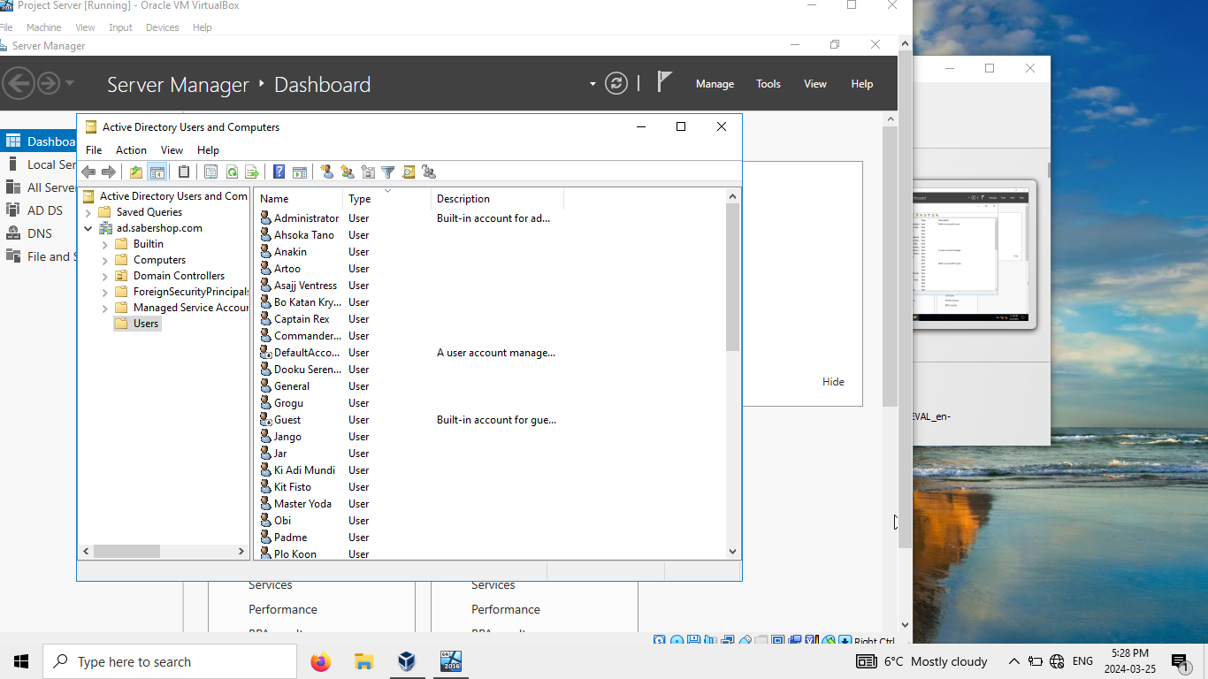

1. Printers and Permissions

Pool printer for office managers

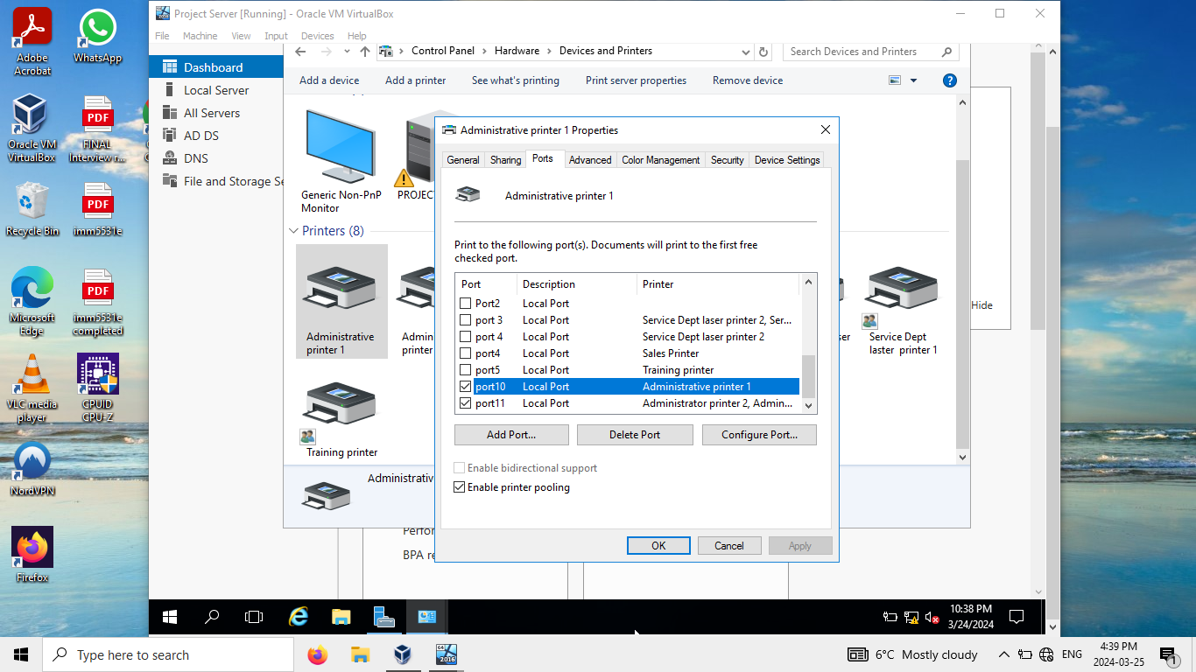

Pool printer for service dept

Permissions

Administrator printer permissions

Sales printer permissions

Training printer permissions

1. Workstation joined to domain

1. Shared Folders

Padme user with share permissions to all folders

1. Padme user with shared printer access

